Problem statement
People run multiple AI agents with real-world access. For example, coding agents get access to repositories and MCP servers, while email agents can access personal inboxes and calendars. Each agent maintains its own history and can collaborate with other agents, but they can also potentially lead to security risks, exposure to sensitive information, and conflicting actions between agents.
Idea
My idea is to build a platform (steward) that acts as a central control layer for all agents. Instead of allowing agents to directly access tools and models, every tool call and model interaction would pass through this platform. This would provide a single place to monitor, track, and audit agent activity, such as what actions were performed, what resources were accessed, how much was spent, and which agents interacted with each other.
Deliverables:
- A morning brief summing up night with at most question
- An approval card when an agent wants to do something risky
- A page per agent showing its pass, spending and log
How it works:
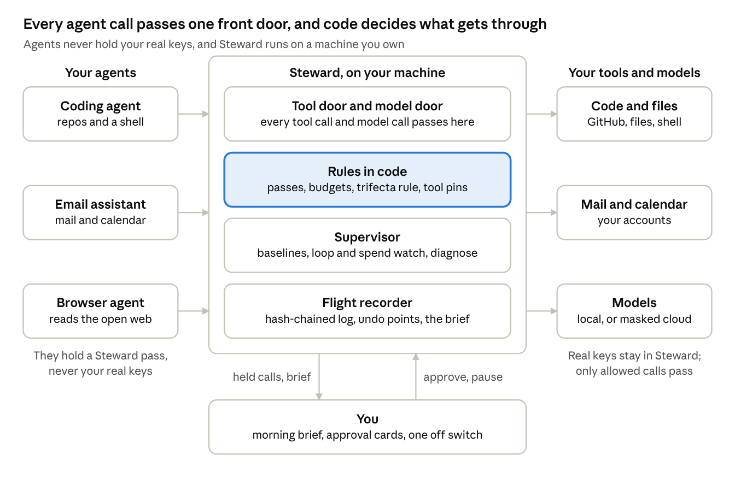

Requirements I aim to work on
- Always-on: A watcher reads the flight log every minute for errors and spend spikes and behaviour outside each agent’s normal pattern
- Private, under user control: Runs on own machine or cloud account. Credentials/sensitive info is stored in steward’s encrypted vault instead of giving it to agents directly (because if agent is compromised, those credentials could be exposed). The secrets are also masked before a model call leaves
- Persistent memory: Remember each agent’s pass, pattern, past incidents, decision made, shared notes agents will read.
- Reusable skills & on-demand skill creation
- Controlled access: Every agent gets a list of what tools it can use, read/write, and budget. Tools outputs are evidenced, and calls are held for untrusted content and private data.
Inside Steward:
- Homebase: Home server or cloud account 24/7; storage shift between local and cloud
- Channels: A chat app for the brief and approval cards, a local web page per agent, and voice we plan to add
- Orchestrator: Reads the ask, each call is checked, then refused or held. Don’t know if we should add agent team or make code decide every decision. Supervisor runs on a schedule
- Model router: sends each agent's calls to the model its pass allows, within budget; the supervisor's own model is local
- Memory
- Skills
- Tool gateway: Read/write tools + on-demand tool creation
- Action Engine: Hold, approve, intend, execute once, record
- Scheduler: Watcher every minute, brief every morning, red-team every week
- Audit: record every call, decision, cost and result -> one per agent

